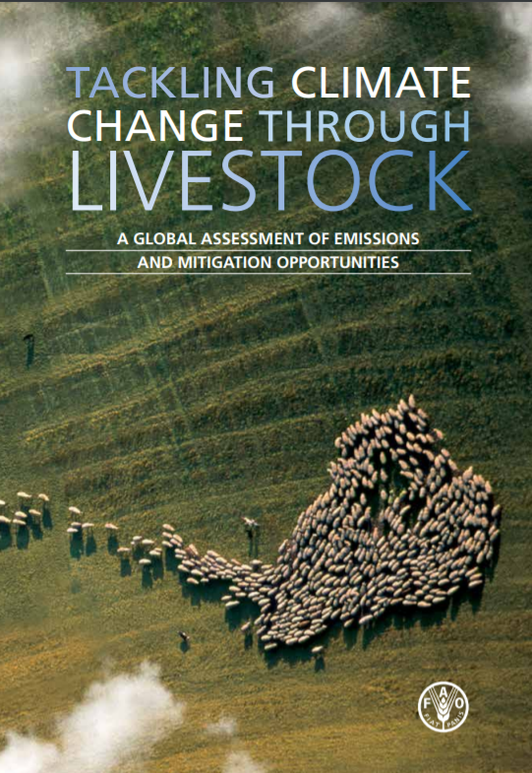

It is easy to draw a dramatic picture of today’s world. Climate change, the most serious environmental challenge humanity has to face, is threatening the well-being of the next generation. Globalization has led to rapid economic, social and technological changes that have left too many behind. Hunger is still a persistent problem, affecting over 900 million human beings worldwide. Faced with these issues, we sometimes feel overwhelmed by their magnitude and powerless. But we need not despair. Difficult problems can be tackled for the benefit of many if we apply the right policies that support the required innovation and investment. We have known for several years that livestock supply chains are an important contributor to climate change. This new report shows that the potential to significantly reduce emissions exists and is within reach. Options are available for all species, systems and regions. But we need political will and better policies. The report provides much-needed data that will allow us to move forward. It presents an evidence-based picture of emissions with data broken down by species, agroecological zones, regions and production systems. The breadth of information provided by this report and the two complementary technical reports1 reflect the vast diversity of the livestock sector. A detailed understanding of the magnitude, sources and pathways of emissions is essential to inform policy dialogue and avoid oversimplifications. It will help us to make more informed choices about livestock policies in support of sustainable food production, economic growth and poverty alleviation. This report identifies ways of reducing emissions by assessing the mitigation potential of sets of technologies. Such analysis provides guidance for local and system-specific solutions, as sector actors seek to improve sustainability and viability, but also for more targeted pro-poor livestock development. The work of the Food and Agricultural Organization of the United Nations (FAO) in assessing the environmental impact of livestock production has triggered the interest and support of multiple partners engaging with FAO to improve data and analysis. The Livestock Environmental Assessment and Performance (LEAP) Partnership focuses on the development of broadly recognized sector-specific guidelines and metrics for assessing and monitoring the environmental performance of the sector. Increasingly, sector actors realize that the growing scarcity of natural resources may well shape the sector’s future and they have started to address its environmental impact. Reflecting these concerns, a wide range of partners have engaged in a global policy dialogue with FAO. The Global Agenda of Action in support of Sustainable Livestock Sector Development aims to catalyse and guide stakeholder action towards the improvement of practices for a more efficient use of natural resources. This Technical Summary to the IPCC Special Report on Climate Change and Land 1 comprises a compilation of the chapter executive summaries illustrated with figures from the report. It follows the structure of the SRCCL and is presented in seven parts. This provides a synopsis of the main issues addressed in the Special Report, introducing key concepts and definitions and highlighting where the report builds on previous publications. focuses on the dynamics of the land–climate system .It assesses recent progress towards understanding the impacts of climate change on land, and the feedbacks land has on climate and which arise from altered biogeochemical and biophysical fluxes between the atmosphere and the land surface. examines how the world’s dryland populations are uniquely vulnerable to desertification and climate change, but also have significant knowledge in adapting to climate variability and addressing desertification. assesses the urgency of tackling land degradation across all land ecosystems. Despite accelerating trends of land degradation, reversing these trends is attainable through restoration efforts and improved land management, which is expected to improve resilience to climate change, mitigate climate change, and ensure food security for generations to come. focuses on food security, with an assessment of the risks and opportunities that climate change presents to food systems. It considers how mitigation and adaptation can contribute to both human and planetary health. introduces options for responding to the challenges of desertification, land degradation and food security and evaluates the trade-offs for sustainable land management, climate adaptation and mitigation, and the sustainable development goals. further assesses decision making and policy responses to risks in the climate-land-human system.

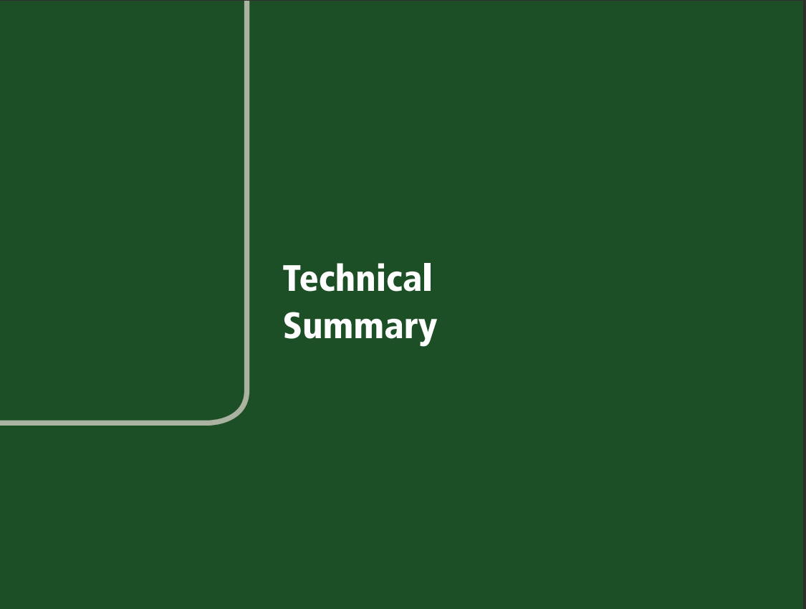

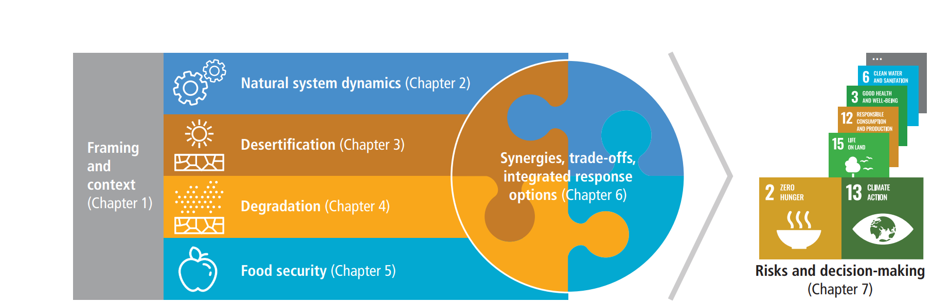

Land, including its water bodies, provides the basis for human livelihoods and well-being through primary productivity, the supply of food, freshwater, and multiple other ecosystem services (high confidence). The current geographic spread of the use of land, the large appropriation of multiple ecosystem services and the loss of biodiversity are unprecedented in human history (high confidence). Warming over land has occurred at a faster rate than the global mean and this has had observable impacts on the land system (high confidence). Urgent action to stop and reverse the over-exploitation of land resources would buffer the negative impacts of multiple pressures, including climate change, on ecosystems and society (high confidence). Rapid reductions in anthropogenic greenhouse gas (GHG) emissions that restrict warming to “well-below” 2°C would greatly reduce the negative impacts of climate change on land ecosystems (high confidence). In the absence of rapid emissions reductions, reliance on large-scale, land-based, climate change mitigation is projected to increase, which would aggravate existing pressures on land (high confidence). Nonetheless, there are many land-related climate change mitigation options that do not increase the competition for land (high confidence). Many of these options have co-benefits for climate change adaptation (medium confidence). Sustainable food supply and food consumption, based on nutritionally balanced and diverse diets, would enhance food security under climate and socio-economic changes (high confidence). A gender-inclusive approach offers opportunities to enhance the sustainable management of land (medium confidence). Regional and country specific contexts affect the capacity to respond to climate change and its impacts, through adaptation and mitigation (high confidence). Cross-scale, cross-sectoral and inclusive governance can enable coordinated policy that supports effective adaptation and mitigation (high confidence). Scenarios and models are important tools to explore the trade-offs and co-benefits of land management decisions under uncertain futures (high confidence).

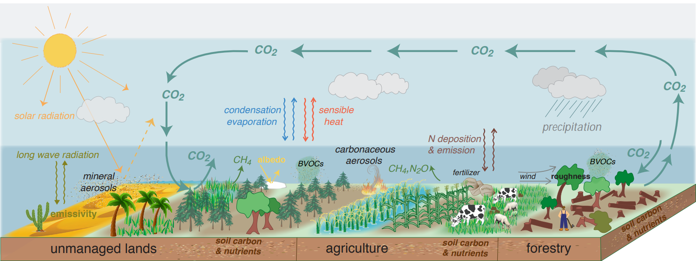

The structure and functioning of managed and unmanaged ecosystems that affect local, regional and global climate. Land surface characteristics such as albedo and emissivity determine the amount of solar and long-wave radiation absorbed by land and reflected or emitted to the atmosphere. Surface roughness influences turbulent exchanges of momentum, energy, water and biogeochemical tracers. Land ecosystems modulate the atmospheric composition through emissions and removals of many GHGs and precursors of SLCFs, including biogenic volatile organic compounds (BVOCs) and mineral dust. Atmospheric aerosols formed from these precursors affect regional climate by altering the amounts of precipitation and radiation reaching land surfaces through their role in clouds physics. The frequency and intensity of some extreme weather and climate events have increased as a consequence of global warming and will continue to increase under medium and high emission scenarios. Global models and national GHG inventories use different methods to estimate anthropogenic CO2 emissions and removals for the land sector. Consideration of differences in methods can enhance understanding of land sector net emission such as under the Paris Agreement’s global stocktake. Terrestrial greenhouse gas fluxes on unmanaged and managed lands Agriculture, forestry and other land use (AFOLU) is a significant net source of GHG emissions (high confidence), contributing to about 23% of anthropogenic emissions of carbon dioxide (CO2), methane (CH4) and nitrous oxide (N2O) combined as CO2 equivalents in 2007–2016.

